Overview & Guiding Questions
Students learn how to represent measurements taken over time on graphs to visualize plant growth on two soil types. Key to any experiment is the value of comparison between groups for testing hypotheses, and comparing observations.
- How do graphs help us to visualize and understand scientific evidence?
- How do you interpret the data in different types of graphs?
- How do you create a graph to visualize and understand your data?

Objectives

Ecological Understanding
- Students will be able to describe how variation in plant growth rates varies under different treatments.

Scientific Process
- Students will be able to identify the major parts of an X-Y graph and interpret a variety of real world graphs.
- Students will create X-Y graphs of their experiment for each soil type.
- Students will begin to use their data to assess whether the evidence supports their hypothesis.

Sense of Place
- Students will begin to understand the implications of their experiment for local ecology.

Time Required
75 minutes

Supplies

- Rulers
- Extra graph paper
- Colored pencils (optional)
- SmartBoard documents

Preparatory Activities
None

Classroom Activities

Students will take their last observations and think about how what evidence they can glean to address their hypothesis from their plants and data charts. Then, students will learn about the elements of an x-y graphs and practice interpreting them, leading into creating their own graphs
of their own data that represent each height over time.

Lesson 7: Visualizing Plant Growth With Graphs

Students learn how to represent measurements taken over time on graphs to visualize plant growth on two soil types. Key to any experiment is the value of comparison between groups for testing hypotheses, and comparing observations.
Did you find it easy or difficult to decide on answers when comparing the heights of plants between soil types? Why?
Are there better ways to measure?
How can we show our plant height measurements?
How do graphs help us to visualize and understand scientific evidence?
What are the points in the graph? What do they represent?

LESSON PLAN OUTLINE
- MAKING FINAL HEIGHT MEASUREMENTS (15 MIN)
- LEARNING ABOUT XY GRAPHS (30 MIN)
- CREATING XY GRAPHS (30 MIN)

LESSON PLAN
- FINAL MEASUREMENTS (15 minutes)
  - Today’s first experimental task is to measure the height of the three bean plants in each of your two pots for the last time. As you measure each toothpick-marked plant, write down today’s height (in centimeters) for each plant on your Plant Growth Datasheet under the correct soil type. Since it is the last day of data collection, make sure that your datasheet is completely filled out. Check that Day of Experiment is complete (write these numbers on the board next to the dates so that everyone can be sure it is correct).
Adapt This!
This lesson can be taught using nearly any type of experiment with quantitative data that changes over time. The data can come from a long-term experiment as in our curriculum, or it can be pulled in from an existing data source for a standalone lesson on graphing.
  - Congratulations—you have all completed the data collection part of our experiment! That was a lot of work, so give yourself a pat on the back. However, we aren’t done yet. It’s time to visualize and analyze our data so that we can better understand our results and make it easy to share them with other people.
  - What was our research question? What was our hypothesis? By looking at your datasheets, can you figure out whether the results of our experiment support our hypothesis? Why or why not?
  - A table full of numbers isn’t the easiest way to understand our results. A graph is a great tool to summarize your data to quickly and clearly understand overall trends.
- GRAPHS CAN HELP YOU TO SEE PATTERNS AND DIFFERENCES (30 minutes)
  - The height measurements that you have been taking can be summarized into graphs that make it easier to see patterns and differences. We’ll take a look at a few different kinds of graphs and see how to interpret them.
  - Project the sample graphs, one at a time: start with a couple of silly graphs (e.g. Cuteness vs. Number of Legs on Animals, Fun vs. Effort for Pets), then move on to a real scientific graph (e.g. CO2 at Mauna Loa). Practice interpreting the graph by asking questions:
i. What is the title? What does this graph show?
ii. The horizontal axis is called the x-axis, and the vertical axis is the y-axis (label them on the Smartboard). What is being measured on each axis in these graphs?
iii. Ask specific questions that the students need to interpret the graph to answer (e.g. If an animal has 6 legs, how cute is it? How much effort and fun is a pet dragon, based on the graph? How much CO2 was there in 2005?). Have students explain how they figured out the answer. Finish with the kids’ growth chart as an example of height measured over time.
Adapt This!
The sample graphs can be modified to include locally relevant or timely graphs, whether silly (age appropriate pop-culture) or serious (current events).
  - Summarize how to interpret and plot locations on an XY graph--Project a blank version of the Bean plant height growth template (Growth charts blank.pdf) on the Smart Board. NOTE: Remind students not to plot the example points on the graph paper they need to plot their own data!
i. This is an “XY graph” that we can use to see patterns in how plants grow over time. Every location within this graph area has an address indicating its location along each of the two perpendicular lines or axes.
ii. The horizontal line is called the X-axis, and it shows us time as our experiment has progressed. It starts at day 0. The first height measurements we took were on Day 7, and today is day __ of our experiment. (Point to these numbers on the X-axis as they are presented).
iii. The vertical line shows us how tall above the ground plants were at each date when we measured them. Question: How “tall” were the plants when we planted the seeds? Answer: We would have measured them as having no height on that day, and so we can say that all plants had a height of 0 on day 0 of the experiment. So, we draw a filled-in circle at the (x, y) point (0,0) that represents all three seeds planted on that day. (The point (0,0) is called the “origin” of an XY graph.) At this time, all of our graphs should look like this:
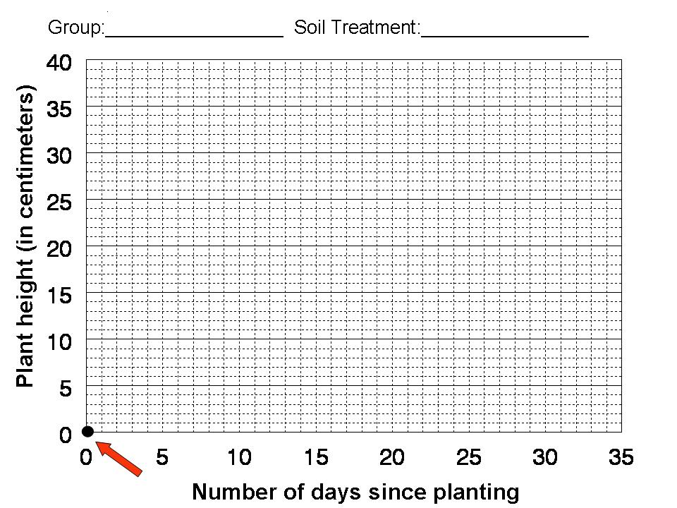

    - Any location on this graph can be located by knowing its x value and its y value (we describe the address in the following format: (x,y). The first number of the address is the X value and the second number is the Y value.
      - Question: Where is point (10,40) on the graph? (Student volunteers can come forward to locate that point)
      - Question: Where is point (30,35) on the graph?
      - Question: What does the point (30,35) really represent? Answer: We have to read the descriptions of each axis to know what points represent. On this particular graph, the point (30,35) represents a plant measured on day 30 of the experiment that was 35 centimeters tall.
    - Project a blank graph with a datasheet next to it, and fill in some example data (can make it up or borrow from students). Any height measurement that we’ve made in our experiment can be mapped to a point (x,y) by knowing the day on which it was measured (x). Let us say that on day 7 (that means that x=7), you measured the height of three plants in your non-serpentine pot, and those heights were: 5 cm, 6.9 cm, and 2.5 cm (or the sample numbers you have chosen). These are the y-values corresponding to the three measurements. We can plot the first new height measurement (5 cm) by finding day 7 on the X axis, and then moving upward until we are directly across from the value 5 on the Y axis. We can mark the location of that observation on the graph at point (7,5), as shown below.
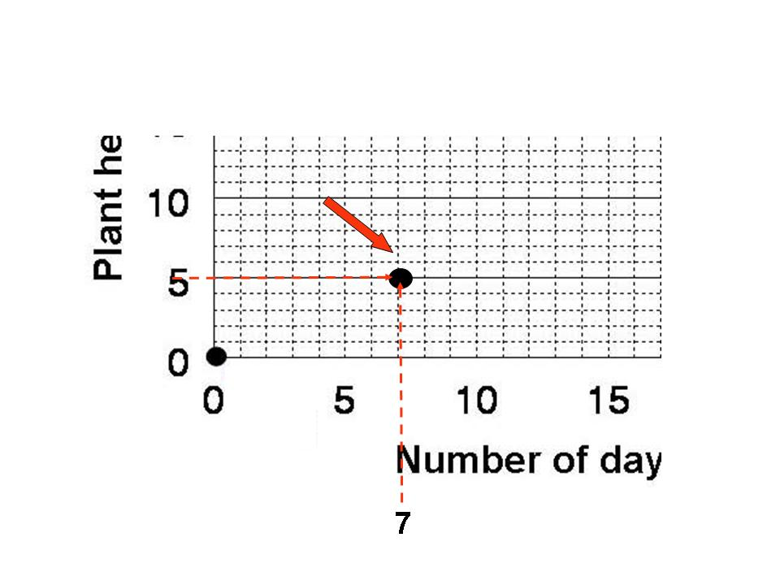
    - Now, following the same procedure (starting at day 7 and moving upward), we mark the two points that correspond to the next two plant measurements: point (7, 6.9) and point (7, 2.5). We can use different symbols or colors for each plant. If using shapes, write the shape we will use into the datasheet under the color name so that we don’t forget which is which (do this on the example datasheet on the Smartboard). Circle is pink, triangle for blue, square for yellow/green.
III. MAKE XY GRAPHS FOR EXPERIMENTAL BEAN PLANTS (30 MINUTES).
a. At this time, each group should plot their own bean plants’ height over time, by plotting data from their plant growth datasheet onto two blank graphs (Growth charts blank.doc). It’s usually easiest for students to take the datasheet out of the binder, so that they can look at the datasheet and graph side by side. Also, this part works best when teachers work directly with teams or individual students. Explain the process, but if they don’t understand completely, it is usually better to move on to going around and helping at their desks one-on-one.

i. To distinguish the two soil treatments, one graph should be labeled “Serpentine”; the other should be labeled “Non-serpentine.”
ii. For each Experiment Day located along the X-axis, students should plot three plant height measurements (one toothpick color at a time) by comparing the heights they measured to values on the Y-axis. Alternatively, they can do each day for one toothpick color, then go back to Day 0 for the next, etc. First, start with the plant marked by the pink toothpick. Plot the Pink plant’s “height” when it was planted on Day 0. Next, plot the Pink plant’s height on Day 8 (or whatever the next measurement day is), and then continue plotting for the other days on which this plant was measured. Next, connect the points you’ve drawn in pencil with a ruler. Once your graph is complete for the Pink plant, trace over your points and connect them with lines in pink. This graph is a picture of how this individual plant has grown over time!
iii. Repeat this procedure for the Blue plant, and then for the Yellow plant. Always remember that data points and connecting lines should be sketched in pencil until the other team member confirms that each point is plotted correctly. THEN, add the color! (Or, if you don’t have colors, use shapes.)
b. Using graphs for comparison-- Now that you’ve all made your graphs, each team should place the graphs for your serpentine and non-serpentine pots side by side, so that the X-axes are lined up as closely as possible.
i. Question: Can you see how the graphs give you a visual picture of how plants are growing over time on the two soil types? Have the plants stopped growing, or are they still growing fast? (Likely answer: Bean plants still seem to be growing fast, as their heights are not showing any signs of “leveling off” on the graphs.)
ii. Question: From the graphs, does it look like your plants are growing at the same speed over time, or are they growing faster or more slowly over time? (This is an advanced topic, but let the students try to understand how they could use the graphs to figure it out.) Answer: On an XY graph, a steeper upward curve or slope means faster growth.
Iii. Question: Do the graphs help you understand whether your data supports your hypothesis? Why or why not? Is it better than the datasheet? Why or why not? How does having one line for each plant helpful? How is it unhelpful? Since plant heights within a pot are different, we need to learn how to calculate “average” plant height to better understand whether our hypothesis is supported. That is the goal for Lesson 8.

PREPARATION FOR LESSON 8:
Davis instructors should photograph the Plant Growth data sheets for calculating class averages only if there is time.

Assessment for Lesson 7

Team/Student Name(s):____________ Date: ___________________

Level of Understanding  Indicator | Engaged  1 points | Emerging  2 points | Proficient  3 points | Total Points
Scientific Recording  (3b & L7.doc Plant Height Graph)  Teams of students accurately record and represent their data! | Team makes numeric observations of plant height and 25% are reflected accurately in graphs and graphs are correctly labeled. | Teams makes numeric observations of plant height and 60% are reflected accurately in their graphs and graphs are correctly labeled. | Teams numeric observations of plant height and 80% or more are accurately reflected in their graphs. Graphs are correctly labeled.
Scientific Skill Development:  (3a)  Student displays understanding of variation. | Team only states that new bean plants are either taller or shorter and makes no comparison with their own. | Team states that new bean plants observed vary, some are taller some are shorter and makes no comparison with their own. | Team describes that new bean  Plants, some are shorter others are taller making it difficult to compare with their own bean plant.
Ecological  Understanding  (3b & 3c) | Team makes 1 clear observation and connection between bean plant growth and soil type. | Team makes 2 clear observations and connection between bean plant growth differences to soil types. | Team makes 2 clear observations and connection between bean plant growth differences and similarities, to soil types and makes references to the influences of time.

